LAB 10: Terraform Commands

Q-1 Which command can be used to create a visual representation of our terraform resources?
A-1 terraform graph

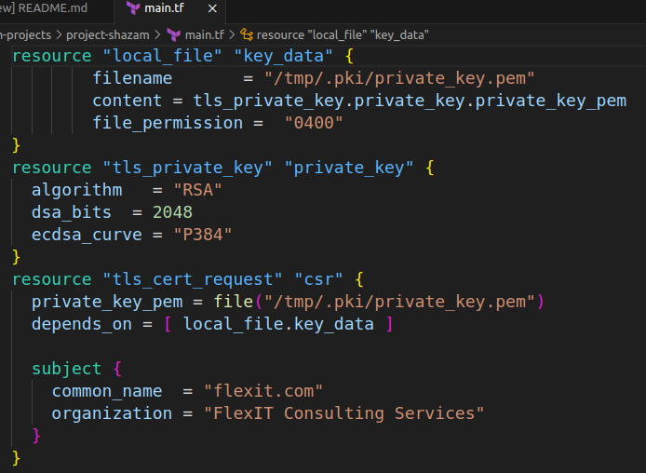
Q-2 We have created a configuration directory /root/terraform-projects/project-shazam. The configuration file inside will be used to create an RSA type private key and then a certificate signing request or a csr using this key.
However, there is an error with the configuration.
Use the terraform validate command, troubleshoot, and fix the issue.

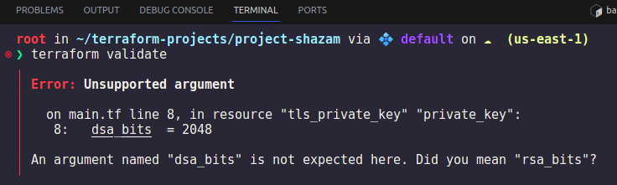
You don't have to create the resources yet! You only need to fix the errors reported by terraform validate.
A-2 terraform validate
Here, mistake in line: 8
dsa bits – incorect
rsa bits – corrected

Q-3 Great! If you completed the previous question correctly, terraform validate should have passed!
Now run terraform plan and generate a configuration plan.
Did it work?
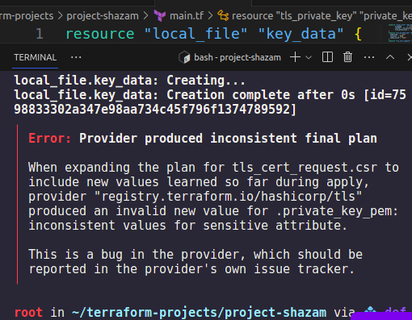
A-3 Yes

Q-4 Now, try creating the resources with a terraform apply.
Did that work?
A-4 No.
Why ?
We did terraform validate.
It’s working well.

Bcz, The terraform apply failed in spite of our validation working!
This is because the validate command only carries out a general verification of the configuration.
It validated the resource block and the argument syntax but not the values the arguments expect for a specific resource!

Q-5 The error in the configuration is inside the resource block for the tls_private_key type resource.
It contains the configuration that we needed for generating rsa type key..
Inspect the resource block and fix the issue.
Once done, run terraform plan and then apply to created the resources.
A-5
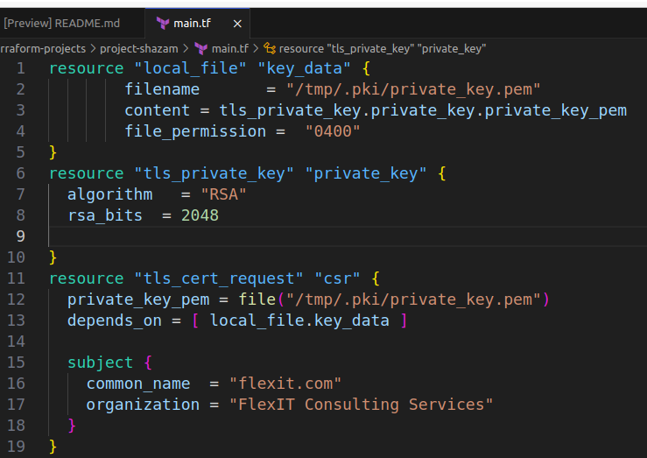

# ECDSA key with P384 elliptic curve
resource "tls_private_key" "ecdsa-p384-example" {
algorithm = "ECDSA"
ecdsa_curve = "P384"
}

# RSA key of size 4096 bits
resource "tls_private_key" "rsa-4096-example" {
algorithm = "RSA"
rsa_bits = 4096
}

# ED25519 key
resource "tls_private_key" "ed25519-example" {
algorithm = "ED25519"
}
ECDSA When algorithm is ECDSA, the name of the elliptic curve to use. Currently-supported values are: P224, P256, P384, P521. (default: P224).

RSA When algorithm is RSA, the size of the generated RSA key, in bits (default: 2048).

Refer docs :-
https://registry.terraform.io/providers/hashicorp/tls/latest/docs/resources/private_key

Q-6 Now format the main.tf file into a canonical format.
A-6 terraform fmt – this is for formatting your config file into std format.

Q-7 Now, navigate to the directory /root/terraform-projects/project-a. We have already created the resources specified in this configuration.

Fetch details from the state file and identify the value of the filename argument.

Note: Do not rely on the current value in the configuration file.

A-7 root/codes.
Why? The config directory is “/root/terraform-projects/project-a”.
Bcz, we did not apply terrafom apply yet. So resource has not created.
So, file “codes” is not in our config directory , it is in “/opt/codes” directory

When we apply terraform apply , the file “codes” will created in “/root/codes” directory.

Q-8 In these terraform labs, we have used multiple providers so far. But, what are providers?
A-8 https://www.terraform.io/docs/configuration/provider-requirements.html#about-providers

Provideres are actually plugins.

Q-9 Which one is a valid sub-command of the terraform providers command?
A-9 Run terraform providers - -help command. Bcz, we don’t know what is sub command of providers command

terraform providers --help

Usage: terraform [global options] providers [DIR]

Prints out a tree of modules in the referenced configuration annotated with
their provider requirements.

This provides an overview of all of the provider requirements across all
referenced modules, as an aid to understanding why particular provider
plugins are needed and why particular versions are selected.
Subcommands:
lock Write out dependency locks for the configured providers
mirror Save local copies of all required provider plugins
schema Show schemas for the providers used in the configuration
So, Ans is mirror, lock & schema.
Q-10 A new configuration directory /root/terraform-projects/provider has been created. We have already run the terraform init command.
Now check the provider plugins that have been downloaded from the command line utility (instead of inspecting the .terraform directory). After that choose the correct option.

A-10 terraform providers

root in ~/terraform-projects/provider via 💠 default on ☁️ (us-east-1)
❯ terraform providers

Providers required by configuration:
.
├── provider[registry.terraform.io/hashicorp/aws] 4.15.0
└── provider[registry.terraform.io/hashicorp/local]

Ans is two providers are installed , 1. aws 2. local.

